Niobium (Nb) based Superconductors: Nb3Sn, NbTi
Enough (raw) Niobium Production:
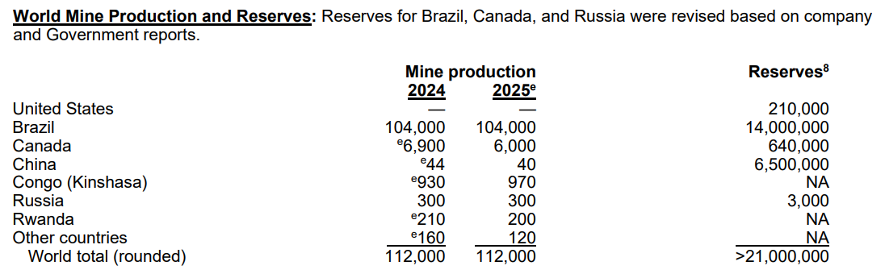
Thus, it is the production rate of Nb-based magnets not the procurement of raw materials
For instance, procurement of Sn and Ti is not a concern.
The production of NbTi is rather mature:
https://www.360researchreports.com/market-reports/nbti-superconducting-alloy-market-202117
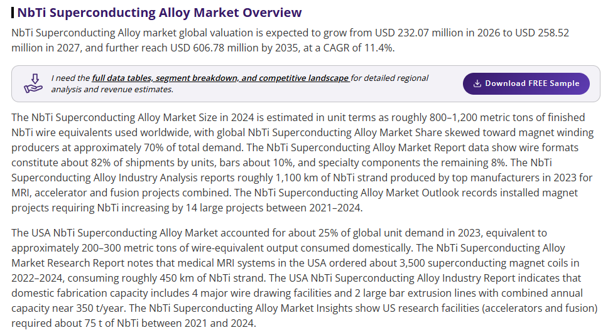
In 2024, approximately 1,000 metric tons of NbTi is produced. Expected CAGR is about 11%. Thus, for a single EU-DEMO reactor, which requires less than 100 tons of NbTi, we expect it not to incur any bottleneck issue.
A bit complicated for Nb3Sn
https://www.iter.org/machine/magnets
(Quote) For the most technically challenging raw material—the niobium-tin (Nb3Sn) superconducting strands used in ITER's toroidal field and central solenoid magnet systems—500 metric tons of strand (more than 100,000 km) were produced by nine suppliers in a procurement effort that lasted from 2008 to 2015. This large-scale industrial effort demanded a ramp-up of global production capacity from 15 metric tons/year to 100 metric tons/year, as well as the introduction of three new strand suppliers.
The question would be, is it easy to ramp up the production rate of Nb3Sn when there is enough demand!
Ps) EU-Demo requires approximately 500 tons of Nb3Sn for startup
- Wrote an email to inquire about information to KAT (one of the vendors for Nb3Sn)

